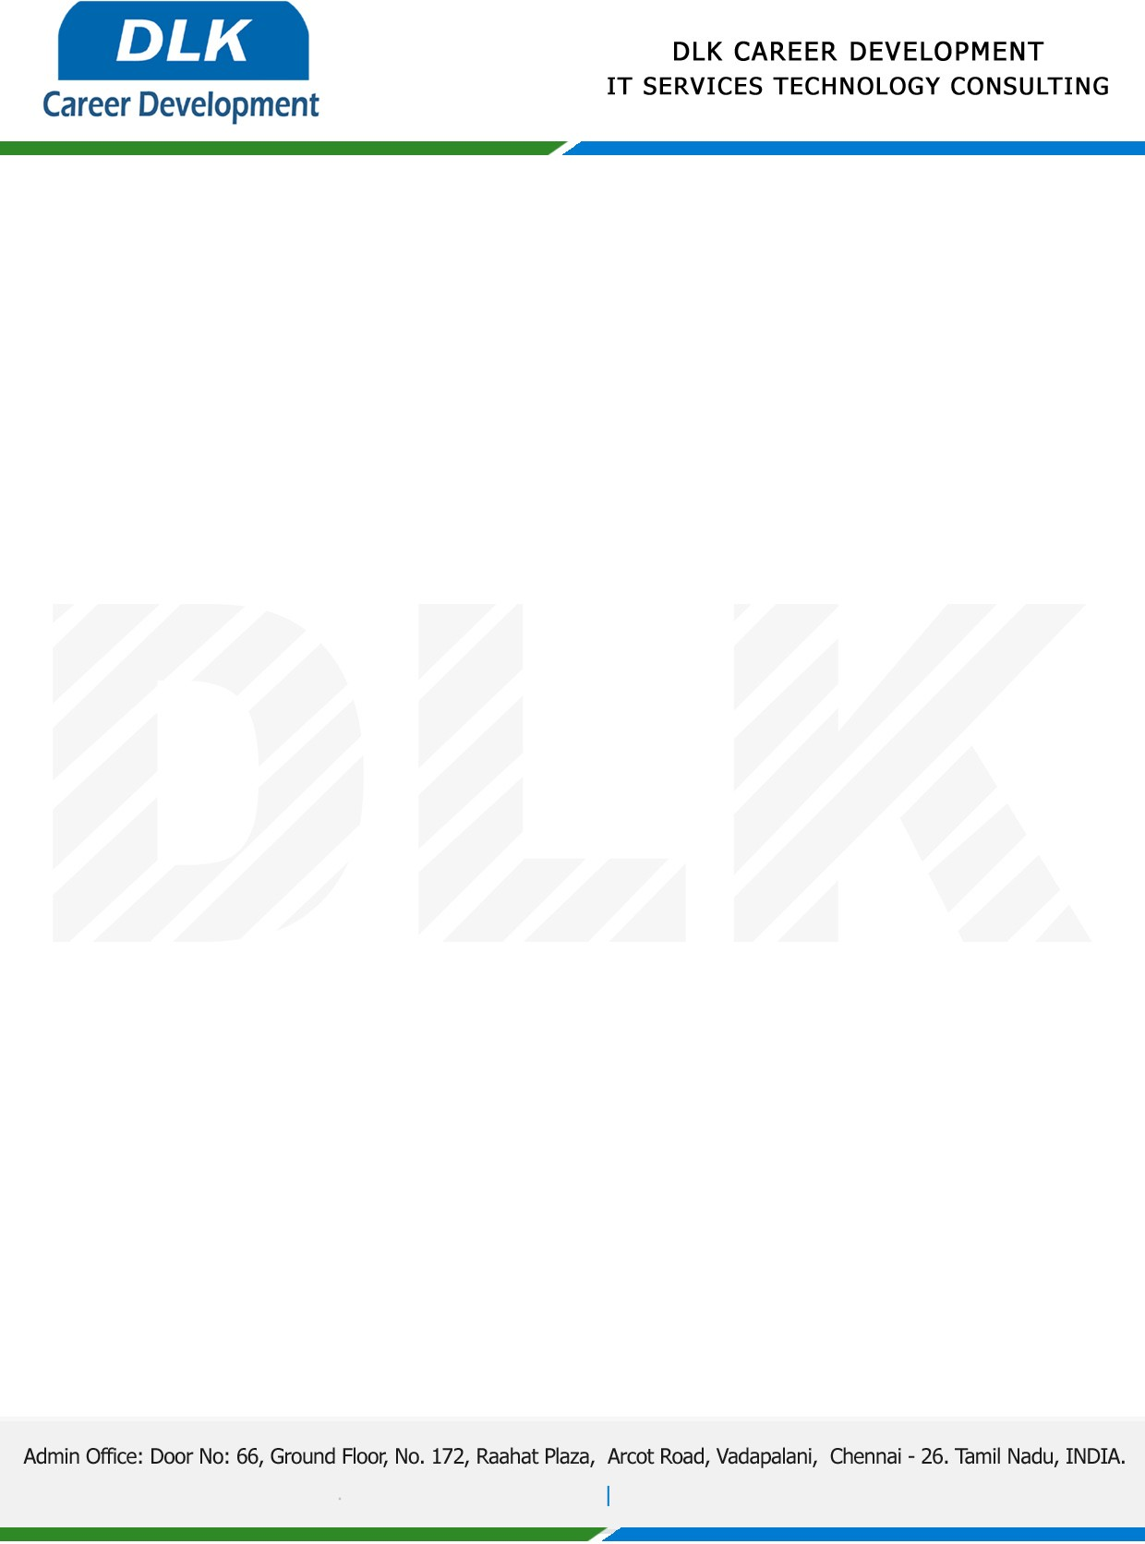

**Date: 02/ March /2023**

**SUB: PROJECT COMPLETION CERTIFICATE**

This is to certify that **MR SRINIVASAN R (REG NO:** **212002785) BCA- Computer Application,** final year student **Alpha Arts and Science, Chennai** has Successfully Completed the Project Work under the domain of “**Blockchain”** in our organization during the Period **(February 2023 to April2023).**

**Topic:** Counterfeit items detection by QR code using Blockchain Technology.

We appreciate your interest in **DLK CAREER DEVELOPMENT**

**“Best Wishes for Your Future Endeavors “**

